Error: Reference source not found
–
Document ID: 0000.doc
Author(s): Madhesh N
Version: 0.2
Date: November 22,2024

1. Objective and Scope 3
2. Project End Users 3
3. Features 4
3.1 Login to the system 4
3.2 Add/Edit User 4
3.3 Permission 4
3.4 Edit Email Content 4
3.5 View Gas Details 6
3.6 View Transaction Details 7

4.Module Description
4.1 Admin Module
4.2 Consumer Module
5. Non Functional requirements
- High Level Design
- Diagrams:
  - Use case Diagram
  - Class Diagram
  - Entity Relationship
  - Sequential Diagram
8.Report

Objective and Scope

Objective
The goal of the Online Gas Booking System is to make it easy for people to book gas cylinders online. This system will help both customers and gas companies by making the booking process faster and more efficient.

Scope
This system will include features for registering users, booking gas cylinders, managing user profiles, checking transaction and gas details, and creating reports. It will be available as a web application that users can access from anywhere with an internet connection.

Project End Users

Customers: People who need to book gas cylinders for their homes or business.

Administrators: Staff who manage the system and users.

Features

Login to the system
• Users log in with their email and password.

• The system checks if the login details are correct.
• Shows error messages if the login details are wrong.

Add/Edit User
Add User:
Users are added into the database through the Add User page. Before adding the user, it allows the user to check for any duplicates in the database.
Edit User:
Users who are added through Add User page are saved into the database as a draft, which can be edited by Edit user page.

Permission
Permission is add to each user. Each user can do specified task only except administrator. Permission restrict the user's access level of this system.

View Gas Details
- Users can view different types of gas cylinders.

• Gas details include type, capacity, price, and availability.

• Administrators can manage gas details (add/edit/delete).

View Transaction Details
• Users can see their booking history and transaction details.

• Administrators can see all users' transaction details.

• Transaction details include booking ID, user details, gas type, booking date, delivery status, and payment status.
4.Module Description
This application is divided into following modules
  - Admin Module
  - Consumer Module
4.1 Admin Module
Manage Cylinders :
The admin has access to the cylinders management system. He/She can
add, update and delete the cylinders.
Manage Orders :
As the main functions of the admin, the admin can accept or reject orders
From the consumers on a case to case basis and a list of consumer orders are listed.
Manage Users :
The admin can manage the user’s account. Admin can add, update and
Block users in the system.
Login and Logout :
By default, one of the security features of this system is a secure login and
logout system.

4.2 Consumer Module
Login Page :
Consumers enter their website credentials on this page to gain access in order to log in.
Register Page :
The page where new to the customers, they can create their login credentials for the
website.
Home Page:
The page on which consumers can book their cylinders.
Credit card payment:
This system has an online payment method that uses a credit card payment.
5. Functional Requirements
Registration:
- Add Consumer:
The system shall allow new consumers to add themselves to the system.
- Assign PIN:
The system shall allow front-desk staff to give each consumer a PIN and add it to the consumer record. This ID shall be used by the consumer throughout his/her stay in the agency.
Cylinder Booking:
- Sign IN:
The consumer first needs to sign in to the system with the username and password he/she has provided with. The system needs to check for validation of that username and password and then only allow him/her to access the system.
- Check Availability:
The Consumer must be allowed to see all available options for booking
the Gas . And see if the site is available or not.
- Cylinder Booking:
Then if the Gas Cylinder is available then the site should be booked.

5. Non-functional Requirements
Response Time: The system shall give a response in 1 second after checking the consumer’s information.
Capacity: The System must Support many people at a time.
User-interface: The user-interface screen shall respond within 5 seconds.
6. High Level Design
The classes used in Online LPG booking system are ,
- Main class - Admin
- Login
- Adduser
- Booking
- Gas
- Price
- Payment
- Delivery
- Database
The methods used under the classes are,
- Main :
main( )
- Login:
userVerification( )
- Adduser:
process( )
4.Booking:
Booking( ) Status( ) getStock( )
5. Gas:
Gas( ) getType( ) getStock( ) getRate( ) GasInfo( ) 6. Price:
getprice( ) getgasrate( )
- Payment:
Payment( )
- Delivery:
Delivery( )
- Database: getConnection(

7.Diagrams:
  - USE CASE Diagram:
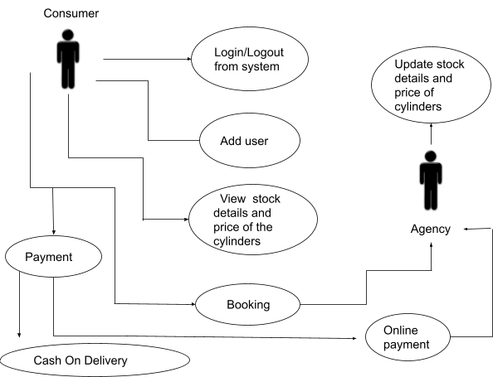

  - Class Diagram:
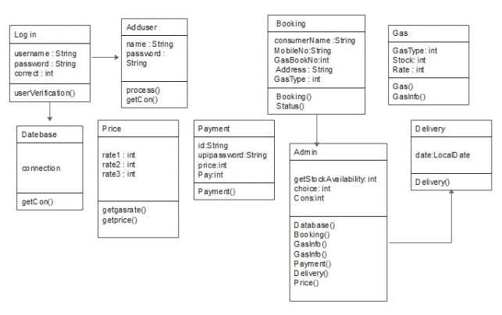
  - ER Diagram :
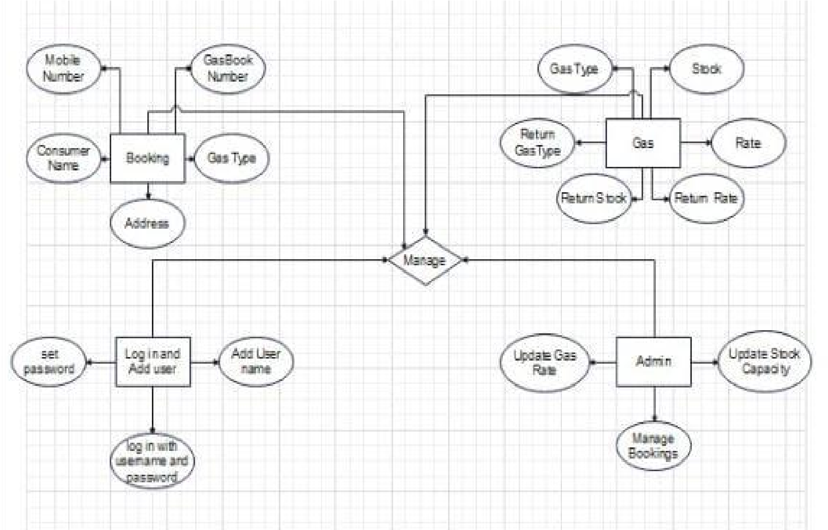

  - SEQUENTIAL DIAGRAM :
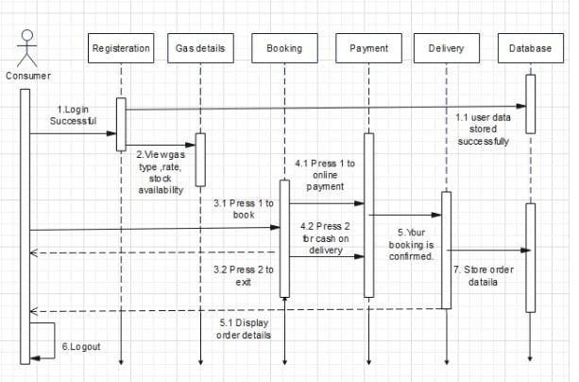

8. REPORT :
The successful implementation of this system will provide a streamlined and efficient solution for managing gas bookings, benefiting both customers and service providers.

